

2026 Project Work Plan

Diamond Lake Area Recreation Association Diamond Lake Aquatic Plant Management Project (Project Number CIP 14-02)

08/13/2025

Fiscal Administration Support: Middle Fork Crow River Watershed District

* Submitted 8/13/2525 for Fiscal Year 2026

**Project Work Plan**I**2026**

## Section 1: Project Summary

**Project Title:** Diamond Lake Aquatic Plant Management Project (Project Number CIP 14-02}

**Project Sponsor:** Diamond Lake Area Recreation Association

**Project Fiscal Administration Support:** Middle Fork Crow River Watershed District

**Project Funding Type:** MS 1030 .701 Project- MS 1030 .745

**Start date:** September 1, 2015

**Support Contact Name:** Andy Johnson District Administrator **Watershed Basin:** Upper Mississippi

189 County Road 8 NE Spicer, MN 56288 **Major Watershed:** North Fork Crow River Watershed

**Phone:** 320-796-0888 **Sub-watershed:** Middle Fork Crow River Watershed

**Email:** [Andy@mfcrow.org](mailto:Andy@mfcrow.org) **Water body:** Diamond Lake

## Section 2: Project Information

The Middle Fork Crow River Watershed District (MFCRWD} and the Diamond Lake Area Recreational Association (DLARA} desire an aquatic plant management plan for Diamond Lake that addresses effective long-term management of aquatic plants and invasive species. MFCRWD and the DLARA have recently managed invasive aquatic plants through the use of harvesters and herbicide application. However, MFCRWD and the DLARA believe a plan that focuses on long-term management will better address improving water quality, lake navigation, and native vegetation health. These goals will be addressed through:

* Identifying the current status of aquatic plants in Diamond Lake.
* Specifying quantifiable management goals.
* Recommending specific management action items to improve lake conditions.
* Developing an annual budget for program implementation.

**Section 3: Budget**

**Diamond Lake Area Recreation Association Aquatic Plant Management Operation Budget:**

**2012 Operation Budget:** $6,000 **2013 Operation Budget:** $6,000 **2014 Operation Budget:** $9,000 **2015 Operation Budget:** $-

**2016 CIP Assessment:** $28,869.18

**2017 CIP Assessment:** $20,000.00 **2018 CIP Assessment:** $20,000.00 **2019 CIP Assessment:** $20, 000.00 **2020 CIP Assessment:** $80,000.00 **2021 CIP Assessment:** $63,500.00

**2022 CIP Assessment:** $60,000.00 **2023 CIP Assessment:** $70,000.00 **2024 CIP Assessment:** $90,000.00

**2025 CIP Assessment:** $150, 000

**2028 CIP (Prop) Assessment:** $0

Initial: _

**Project Work Plan 2026**

***2026 Uses***

**$47,000 Spring Application (PLM)**

**$3000 Pre application meandering survey (Freshwater Scientific)**

**$2,000 Surery of East and West boat landings**

**$2,500 Admin fee to MFCRWD for administration**

**$2,500 Fee to Kandiyohi County for assessment costs**

**$57,000 Total Expenses**

***2026 Sources***

**$ Existing Project funds held by the MFCRWD**

**-$57,000 Total Revenues**

**Section 4: Body of the Work Plan**

##### Objective:

**2026:**

* Statement: Diamond Lake will treat weeds in its 635 acres of littoral water. DNR allows for a maximum of 15%, capping treatment at 95.25. We estimate hiring PLM to treat approximately 88 acres. It is expected private homeowners will treat additional acres. The estimated cost is $47,000. Final cost dependent upon chemical and fuel costs.
* Using data collected by the Watershed District, work with them and others to stive for a long-term plan for improving water quality in Diamond Lake.
* Will perhaps hire company and/or use DNR data to determine whether the carp popular in Diamond Lake should be reduced. If it determines water quality could be measurable improved for fewer carp, harvesting would be paid for from existing DLARA funds.
* Continue to pursue a location for a Nanobubbler and strive to determine if a bubbler would be a cost-effective project for Diamond Lake. Any bubbler installation is likely 2-3 years in the future. Getting assistance from the county and the Watershed is expected to be key for any bubbler installation.

**Initial:**

**Project Work Plan 2026**

## Section 5: Actual Past Outcomes

### Actual Outcomes:

### 2025

### Treated 72.5 acres by PLM.

### DLARA hosted Weedfest on July 19th from 2-7 pm at county park. Enjoyed music by Southern Cross ______, with food sold by DLARA and beverages by Handle Bar. Purpose to raise funds to control weeds and for lake owners to meet. An estimated 320 people attended.

### Continue to review site location for Nanobubbler, review benefit of bubbler at Diamond Lake and work with DNR for permits.

### Reviewed need for a levy in 2026 and after review with WD, determined the amount of funds in our WD account prevented DLARA having a levy in 2026.

### Provided information at annual meeting on how private individual could treat weeds in front of their property. Several attendees expressed they would be pursuing treatment in 2026.

### Create survey to determine what areas of lake or 20 feet deep and 500 feet from shore. This area is approximately 745 areas. Working to develop restrictions for wake boats

### Developed process for obtaining no wake rules for lake

### 2024

### Treated 71.1 acres by PML and had an AIS diver survey

### conducted at both public boat landings.

### DLARA hosted WEEDFEST on July 22nd from 2-7pm at the

### county park to enjoy great music by CURIOSITY food and

### beverages, and help us raise money to control weeds in

### Diamond Lake. An estimated 300 people attended.

### Held emergency meeting to review what actions to take with

### discovery of red algae in southeast portion of lake. Requested

### weekly monitoring and testing by the MFCRWD for red and blue-green

### algae. at multiple locations.

### Worked with Watershed and Moleaer to determine if a nanobubbler

### generator was a good solution for solving Diamond Lake pollution

### problem. Reviewed the Moleaer proposal with the MFCRWD and formed

### a partnership agreement for sharing the system’s costs.

### Determined a levy increase was needed for DLARA nanobubbler

### costs. Calculated how small of levy increase was needed with some

### costs being paid for from existing funds. Created a list of possible funding sources to help cover nanobubbler costs other than from a levy.

### Held an open house informational meeting at the Handel Bar Strong Garage in Atwater on August 24th from 9-12 after

### sending out mailings to update the public on the plan to fund a long-term nano bubble unit for Diamond Lake to reduce

### toxic algae blooms and reduce the legacy phosphorus in the lake bottom

**2023**

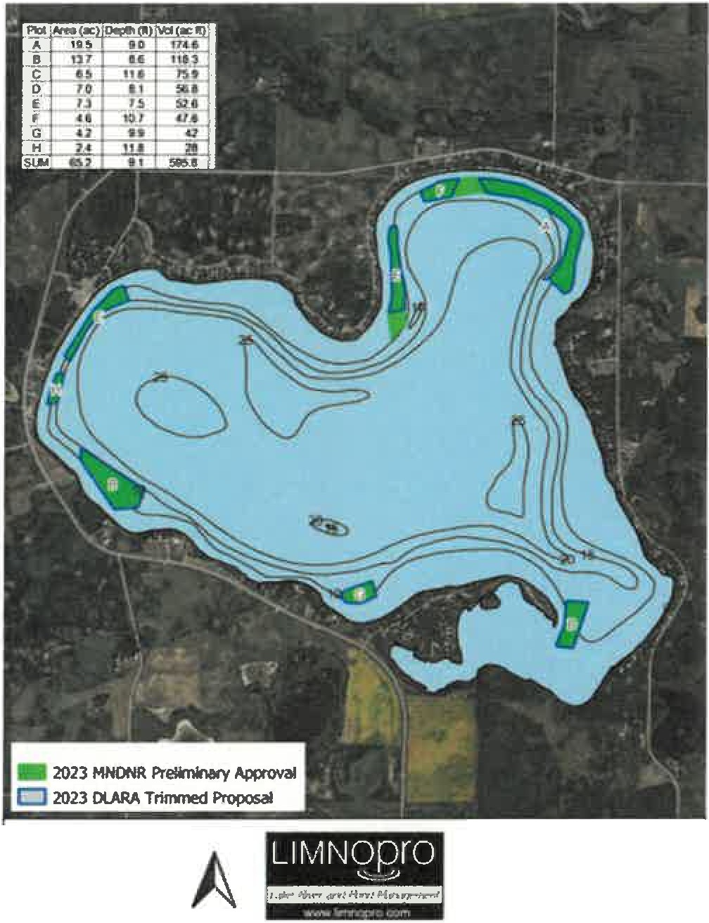

0.25 0.5 mi

**Diamond lake**

**Q.P Permit Appllcatlon (5/16/2023)**

* An extensive survey was conducted under the supervision of Eric Katzenmeyer of the Minnesota DNR for the permitting of the application on May 17, 2023. The DNR's findings of evidence of native plants in shallow areas initially planned for treatment for CLP restricted the area approved for treatment. This resulted in a reduction of total acreage treatment goal of 80 acres, however it was 68% higher than the acreage treated in 2022.
* Limnopro treated 65.2 acres at a rate of 2 ppm over three days ending May 29, 2023 in the following areas of the lake: 31.4a in the north lobe, 22.6a in the western portion of the west lobe, 4.2a in front of the resort and 7.0a off the tip of the peninsula. The mean depth was

9.1 feet resulting in the use of 595.8 gallons of Aquathol

K. The cost for chemical and application expenses was

$69,927.77.

* The Kandiyohi County Water Task Force approved a grant for $7,500 toward CLP treatment expense for 2023. Submission of the report to comply with the terms of the grant will be submitted to the county in September 2023.
* The annual cleanup of the ice scheduled for late winter 2023 had to be cancelled due to unsafe ice conditions. Ice fishing was reduced during the season due to heavy snowfall.

Initial:

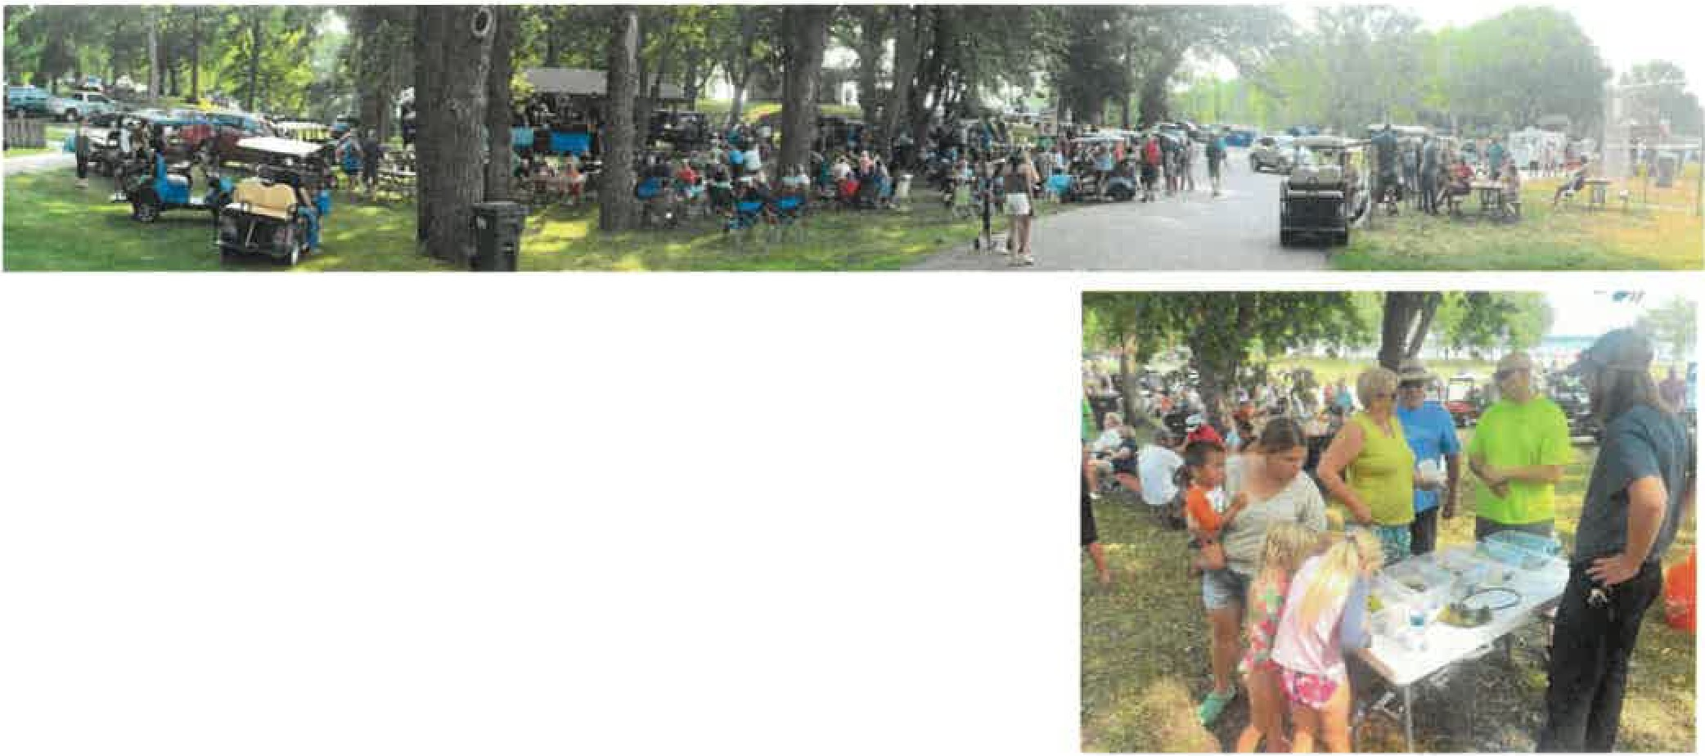

The inaugural Weedfest gala was held on July 22nd and was highly successful with hundreds of people attending the educational and social event. Officials from Limnopro were on hand with a weed identification display, handout materials and were available for questions. The sewer district also had a display and answered questions regarding proper maintenance of sewage disposal equipment.

•

### 2022

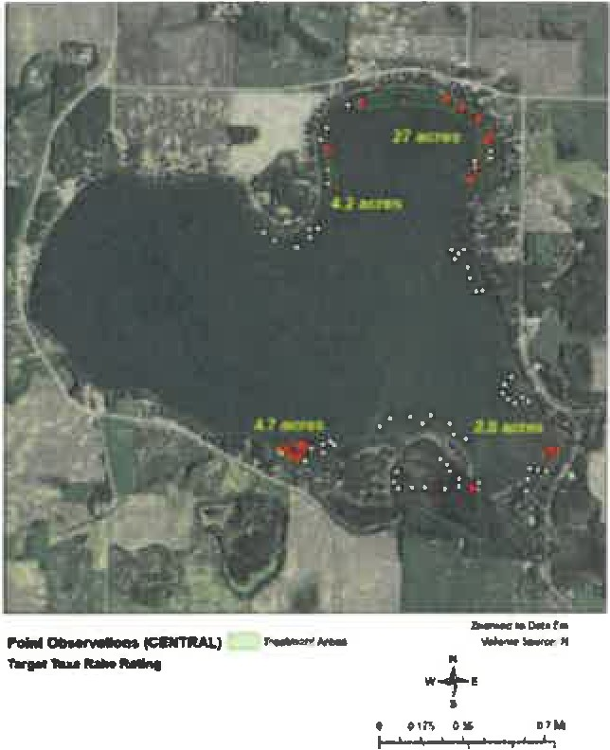

**-**-**•D**-**o**-**ta**.**f**.**-**

* Limnopro treated 38.7 acres at a rate of 2-3 ppm in the northern and southern portions of the lake, excluding Dogfish Bay. The treatment cost for the application of Aquathol K was $55,243.86.
* Extensive survey work took place in the spring with more to be done in the summer. Total cost to access condition and identify treatment areas will exceed $10,000 in 2022.
* The Kandiyohi County Water Task Force approved a $5,000 grant. Submission of the report to comply with the terms of the grant was submitted to the county in August 2022.

### 2021:

During the summer of 2020 a sonar survey over all of the littoral waters of Diamond Lake was performed to measure the biomass of lake vegetation. It was not specie specific. Two abridged point-intercept surveys, based on the biomass data, were later conducted on Diamond in the spring of 2021 by Limnopro and the DNR. Their findings ultimately drove the final June 2021 application areas. The existence of native plant, even in very small amounts, eliminated several areas from treatment consideration in the 80+ acres included in the 2021 plan. Limnopro ultimately treated 40.4 acres at a rate of 2.0 ppm primarily in the northern portion of the lake. The treatment cost for the application of Aquathol K (active ingredient Endothall) was $50,199.09 because the areas treated were in waters deeper than those areas in the original plan. The Aquatic Pesticide Application Record is attached for further details. The Kandiyohi County Water Task Force approved a (9,000 grant in 2020 and submission of the report to comply with the terms of the grant was submitted to the county in August 2021

### 2020:

* Limnopro treated 84.2 acres at a rate of 1.5 ppm primarily in the southern portion of the lake and excluding Dogfish Bay. A .3 acre area near the east county boat ramp was also treated at a more concentrated rate of 5.0 ppm. The treatment cost for the application of Aquathol K was $78,038.59. The Kandiyohi County Water Task Force approved an $8,000 grant and submission of the report to comply with the terms of the grant was submitted to the county in August 2020.

**Initial: *_***

**Project Work Plan**I**2026**

### 2019:

* The Diamond Lake Association Area Recreation Association will hire a lake service provider to survey lake vegetation and invasive curly-leaf. The cost will be between $5,073.65. The cash balance for the CIP is $6,628.69

### 2018:

* PLM treated 20 acres at $575.84/acre. Totaling $11,516.80
* The Kandiyohi County Water Task Force paid 50% of the total project cost.
* The ClP paid 50% of the project cost, $5,758.40.

### 2017:

* PLM treated 20 acres at $435.78/acre. Totaling $8,715.60.
* The Kandiyohi County Water Task Force paid 50% of the total project cost.
* The CIP paid 50% ofthe project cost, $4,357.80.

### 2016:

The CIP paid $7,016.22.

**Signed:**

President, Representative, Diamond Lake Area Recreation Association

# Dated:

**Initial: *_***